For Immediate Release:
Community Groundbreaking Event Celebrated the Start of Construction on
The Strand Residences Affordable Housing Project in DC’s Deanwood Neighborhood

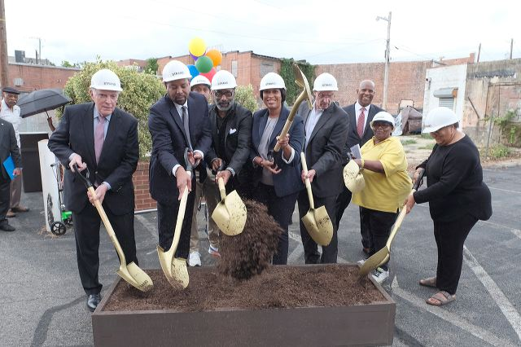
Dick Burns, CEO NHPF, Warren Williams, CEO Warrenton Group, Pastor Stephen Young, WMCDC, Mayor Muriel Bowser, Councilman Vince Gray, Pat Malloy

Washington, DC August 29, 2019 The NHP Foundation (NHPF), The Warrenton Group (TWG) and the Washington Metropolitan CDC (WMCDC) broke ground yesterday on the construction of the Strand Residences, an affordable housing development with 86 one-and two-bedroom affordable apartments in the Deanwood neighborhood of Washington, D.C. at 5109 Nannie Helen Burroughs Ave, Washington, D.C.

The ceremony included remarks from Mayor Muriel Bowser and Councilmember Vincent Gray, both supported the project for many years. The event, an ice cream social for neighborhood residents and local officials, was held after another local affordable housing groundbreaking at the nearby Providence Place.

“Construction of The Strand Residences, in the making for more than a decade, is being financed by DMPED which is investing $15.6M from the District’s New Communities Initiative, DCHFA which allocated $19.5M of tax-exempt bonds, and DCHA which contributed operating subsidies for 28 units through a Local Rent Supplement Program contract (LRSP),” said Mayor Muriel Bowser. “As well, the tax-exempt bonds triggered an allocation of 4% Low-Income Housing Tax Credits that helped attract a $12.3M equity investment from Enterprise Community Partners.”

In addition to the 86 apartments, the Residences will feature a large multi-purpose room, exercise room, bike storage room, outdoor patio area for grilling, and on-site resident services provided by NHPF’s affiliate, Operation Pathways. The first floor also includes retail space for a neighborhood non-profit and a community-based retailer. Construction is expected to complete in January 2021.

"The Strand Residences boldly underscore NHPF’s mission to provide quality affordable housing that’s ‘more than a roof’,” said NHPF CEO and President Richard Burns. “This service-enriched property will bring about positive change for the community and its residents for years to come.”

Added TWG President Warren Williams, “After twelve years of effort by The Warrenton Group, the local ANCs and Lincoln Heights New Communities Resident Council, neither residents nor local businesses were displaced for this project which is critical to preserve a community while still increasing value for Ward 7. Partnerships with local leaders such as Pat Malloy and local resident Councilmember Vince Gray were instrumental in developing the New Community Master Plan its successful materialization. The Strand really is evidence that ‘teamwork makes dreams work’.”
The Strand Residences will be built on land that was contaminated by Volatile Organic Compounds (VOCs) and prevented its redevelopment for years. To ensure proper remediation of the brownfield, the Development Team entered the District’s Voluntary Clean-Up.

“With the Strand, as well as Providence Place development nearby, it is heartening to have these new affordable housing options in our community,” added Pastor Stephen Young of WMCDC.

The Residences is next to the Strand Theater, a storied local historic landmark that the Development Team plans to convert into a new restaurant in 2020.

PGN Architects is the architect of record. Bowman Consulting provided civil engineering, landscape design, and surveying services. WCS Construction is the general contractor and WCS Property Management will be the property manager. The Development Team is committed to spending at least 35% of the project’s funds on products and services provided by Certified Business Enterprises. WCS Construction is committed to meeting the District’s First Source hiring requirements.

Once complete, the Residences will include 71 one-bedroom apartments and 15 two-bedroom units. The 28 LRSP units will be rented to residents who earn less than 30% AMI and will be reserved for residents relocating from the nearby Lincoln Heights and Richardson Dwellings properties.

###
About The NHP Foundation
Headquartered in New York City with offices in Washington, DC, and Chicago, IL, The NHP Foundation (NHPF) is celebrating its 30th year as a publicly supported 501(c)(3) not-for- profit real estate corporation. NHPF is dedicated to preserving and creating sustainable, service-enriched multifamily housing that is both affordable to low- and moderate-income families and seniors, and beneficial to their communities. NHPF also provides a robust resident services program to nearly 18,000 community residents. Through partnerships with major financial institutions, the public sector, faith-based initiatives, and other not-for-profit organizations, NHPF has 52 properties in 15 states and the District of Columbia.

About The Warrenton Group
Since its inception in 1997, The Warrenton Group is an innovator in developing quality mixed-income housing and market-use developments, while creating substantial value for the people and the neighborhoods in which it works. TWG is a full-service development firm that works from conception to completion. It handles development, investment, construction and management with creativity that leads the industry. TWG is responsible for more than $1 billion in development, construction and investment, and has acquired, built or preserved more than 3,000 high-quality residential units and 300,000+ sf of commercial space throughout the DC metropolitan region.

About Washington Metropolitan CDC
The Washington Metropolitan Community Development Corporation is a community-based, non-profit economic development corporation working primarily in Washington, DC’s Deanwood neighborhood. Through its systematic and sustainable community development efforts, it aims to help low-income people realize their dreams of living in a vibrant, affordable community.

